Author | Healing Journey Navigator
Certified Reiki & Sound Therapy Practitioner

I’m available for press interviews and would love to hear from you. You’ll find most of what you need below. To arrange an interview, or for more information, please contact me at SufferingtoThriving@gmail.com.

Press Release

April 12, 2022: https://www.pr.com/press-release/859060

Sample Interview Questions for Kathy

- In 60 seconds, what’s your book about?

- Why is your book important for readers now?

- In your book you share with us that you’ve been on your own healing journey for a few decades – including recently being bed-ridden for five years. Could you tell our listeners more about that?

- What will people learn from the book?

- Drilling down a bit further, your book is a toolkit of practical tools that readers can use to navigate their own healing journey. Could you give us an example or two of the tools?

- What's the one thing you hope your readers would remember from your book?

- What makes your book different from other books available?

- What makes your book easier to comprehend than other "how to" healing books. There is usually a lot of new vocabulary and jargon for a novice.

- After reading your book, if people need help on personalizing the Toolkit for their own healing journey, what can they do?

- How can readers find out more about you? and where can they purchase your book.

Background

- According to the Centers for Disease Control (CDC), six in ten American adults have a chronic disease.

- According to the CDC, “In 2019, 20.4% of [US] adults [50 million] had chronic pain and 7.4% of adults had chronic pain that frequently limited life or work activities (referred to as high impact chronic pain) in the past 3 months.” That’s one in five Americans having chronic pain.

- Everyone – if we’re lucky to live long enough – will face a health crisis at one point or another. Illness, injury, and loss are part of life.

- Your – or your loved one’s – healing crisis has a bigger reason… that perhaps it’s a catalyst for finding meaning and purpose in your life. It could be a blessing in disguise, or portal to a new life – new knowledge, skills, and inspiration.

- If you or someone you know is seriously ill or injured, it’s important to realize that suffering is a choice. You can choose to thrive.

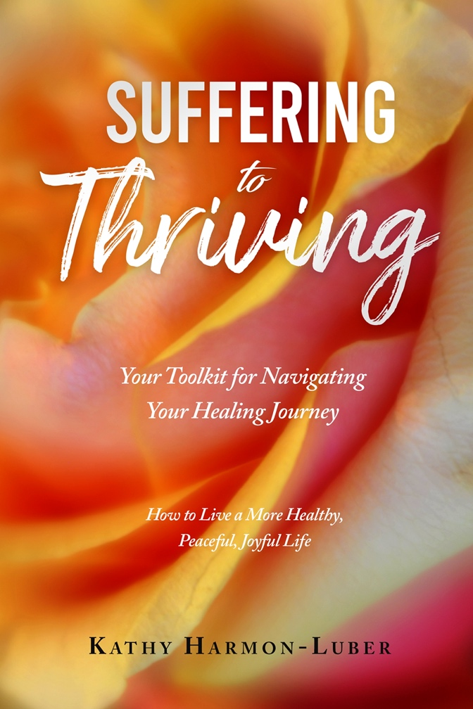

Photograph by Lynne Eodice

Photograph by Lynne Eodice

Photograph by Lynne Eodice

Photograph by Lynne Eodice

Kathy’s Bio

Kathy is an inspiring, compassionate, and empowering author and wellness guide whose passion is helping people navigate the challenging terrain of the healing journey. With insight and enthusiasm, she opens people’s eyes to the potential of becoming more physically, emotionally, and spiritually healthy by offering a toolkit of practical solutions. Her book, “Suffering to Thriving: Your Toolkit for Navigating Your Healing Journey ~ How to Live a More Healthy, Peaceful, Joyful Life,” is full of wisdom gleaned from decades of healing from health crises.

Kathy went from suffering to thriving, reversing the progression of asthma, chronic bronchitis, and autoimmune disorders, and recovered (without surgery) from several debilitating, inoperable spinal diseases and disc ruptures which left her bed-ridden for five years. Kathy’s passion is helping others find their compass and chart a course for navigating illness, injury, and loss – learning how to not only cope, but to become more resilient, joyful, and thriving.

In addition to being a healing journey navigator, Kathy is also a Reiki practitioner, and certified Sound Therapy & Sound Healing practitioner.

There’s more about Kathy’s background at the “About” tab.

Thank you!

“Chronic Diseases in America,” Centers for Disease Control and Prevention (Centers for Disease Control and Prevention, January 12, 2021), https://www.cdc.gov/chronicdisease/resources/infographic/chronic-diseases.htm.
Carla E. Zelaya, James M. Dahlhamer, Jacqueline W. Lucas, Eric M. Connor, “Chronic Pain and High-impact Chronic Pain Among U.S. Adults, 2019,” CDC National Center for Health Statistics, Data Brief No. 390, November 2020.

